**1. Mobile Banking Dashboard:**

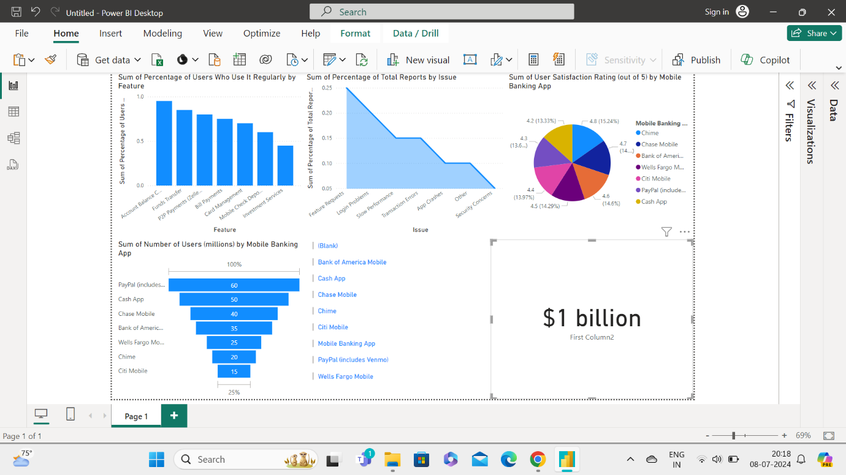

**2. Online Banking Dashboard:**

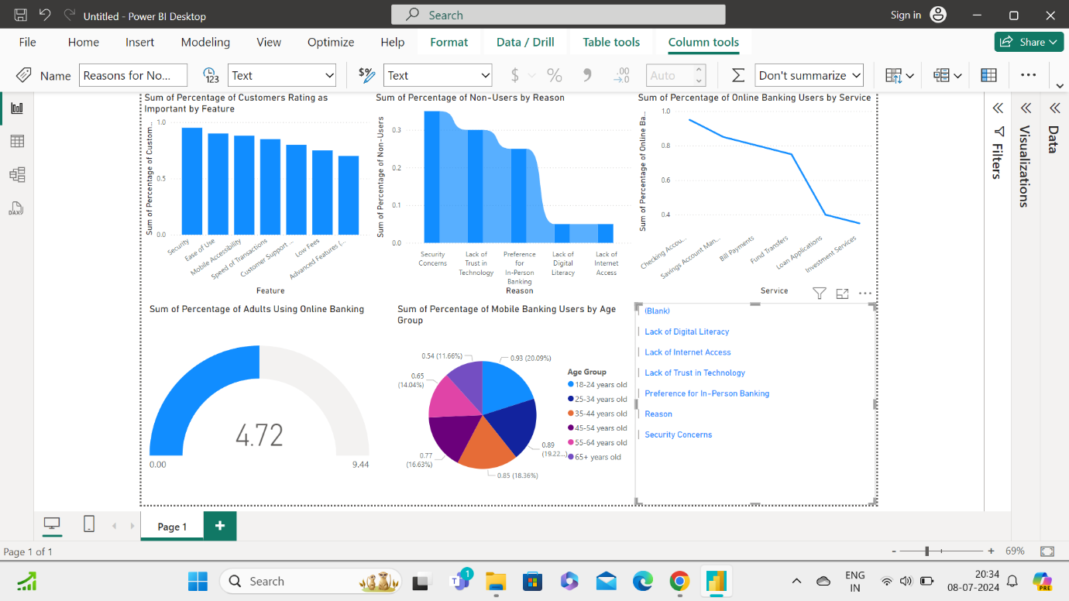

**3. Voice Banking Dashboard:**

